
Carleton University
School of Information Technology
OSS 4006 – Image Processing
Fall 2020
Instructor: Dr. Marzieh Amini
Assignment 2

You must submit the assignment to cuLearn by Nov. 2nd, 2020 at 12 pm.

Q1: Spatial Filtering

Write program to perform spatial filtering of an image. You can fix the size of the spatial mask at 3 x 3, but the coefficients need to be variables that can be input into your program. This project is generic, in the sense that it will be used in following project to follow.

img = imread('Q2.tif');
subplot(1,3,1);
imshow(img);
title('original');

% Mean filter
% value for hsize is [3 3].
h = fspecial('Mean',[3,3]);
img1 = imfilter(img, h);
subplot(1,3,2);
imshow(img1);
title(‘Mean filter');

% Median filter
% B = medfilt2(A) performs median filtering of the matrix A using the default
% 3-by-3 neighborhood.
img2 = medfilt2(img);
subplot(1,3,3);
imshow(img2);
title('median filter')

Q2: Enhancement Using the Laplacian

(a) Use the programs developed in Q1 to implement the Laplacian enhancement technique described in connection with 𝑔(𝑥, 𝑦) = 𝑓(𝑥, 𝑦) + 𝑐[𝛻²𝑓(𝑥, 𝑦)] (b) Duplicate the results in Fig. 3.52.

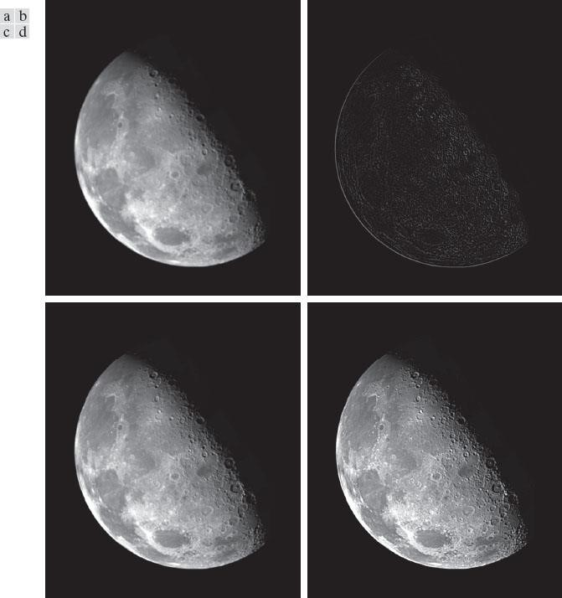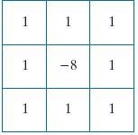

Fig. 3.52. (a)
Blurred image of the
North Pole of the moon. (b)
Laplacian image obtained using
the kernel in Fig. 3.51(a). (c)
Image sharpened using Eq. (3
-
63)

with c = −1. (d) Image sharpened
using the same procedure, but wi
th
the

following

kernel
.

Code:
img = imread('Q2.tif');
subplot(2, 2, 1);
imshow(img);
title('original');

%
h = fspecial('laplacian', 0.2);
img1 = imfilter(img, h);

%
w = [-1, -1, -1; -1, 8, -1; -1, -1, -1];
%'replicate', the image size is extended by copying the value of the outer boundary
img2 = imfilter(img, w, 'replicate');
subplot(2, 2, 2);
imshow(img2);
title('mask');

%
img3 = img + img1;
subplot(2, 2, 3);
imshow(img3);
title('Image sharpened 2');

%
img4 = img + img2;
subplot(2, 2, 4);
imshow(img4);
title('Image sharpened 2');

Output:

Q3: Histogram Equalization

Assume continuous intensity values, and suppose that the intensity values of an image have the
PDF 𝑝_{𝑟}(𝑟) = _{(𝐿−}^{2𝑟}₁₎2 where 0 ≤ 𝑟 ≤ 𝐿 − 1 and 𝑝_{𝑟}(𝑟) = 0 for other values of r.
Find the transformation function that will map the input intensity values, r, into values s, of a histogram-equalized image.

Q4: Fourier Transform

Show that 𝐹{𝑒^{𝑗2𝜋𝑡0𝑡}} = 𝛿(𝜇 − 𝑡₀), where𝑡₀ is constant. 